SUNDAY SAILORS REPORT July 30 2023 – Winter Series Seventh Race

Intro
Sunny skies, no rain, what more could a crew want?? Maybe 5 knots less wind. In a Northerly – fairly flat seas, although some wave surfing occurred approaching No 5, we were treated to 20-22 knots of wind, with occasional gusts to 26-28 knots!! The course was number 40, 10.6 nM which our handicapper Mr Stuart Morrison-Jack, with tower staff Eryl Harris and Christine Walsh, hatched up after some deliberation. The conditions were fair for smaller boats as well as such warhorses as Bacardi and Lumiere. Apologies but all photos are from other races….

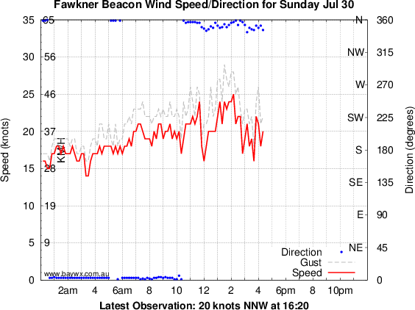

Results
Seventeen boats toed the line with fifteen finishers. Five minutes separated the first four. Emerald (Tony Tanner) sailed very quickly in the conditions to finish first, holding off a fast finishing Lumiere (Matt Kebbell). Third was Alliance (Alex Hall, Simon F, Paul S, Uncle Tom Cobbely and all). Fourth was Winsome (Simon Hemingway- who was actually on the boat) after a race long tussle with Razzle Dazzle (Grahame Jones) who finished fifth. The wind direction was fairly steady although backed slightly easterly on the first reach (and strengthened) and shifted a bit Westerly on the last beat, giving a lift to those further out when they tacked in.

Emerald takes the gun – well Emerald took the gun Photo from another day

Start of the Day
Start of the day was tied at 8 seconds (not too great) with La Mer (Michael Ebeling) and the Skullthuggery crew (Garry MacCarten). Next best was Winsome (11 seconds), Upbeat (Peter Dunne) – 12 seconds , Bacardi (Martin Power) also 12 seconds. Peter Dunne was heard complaining that he had right of way on the line and Winsome barged in on port and tacked in front of him. Not so Upbeat after all. Discussions were held in the bar afterwards apparently.

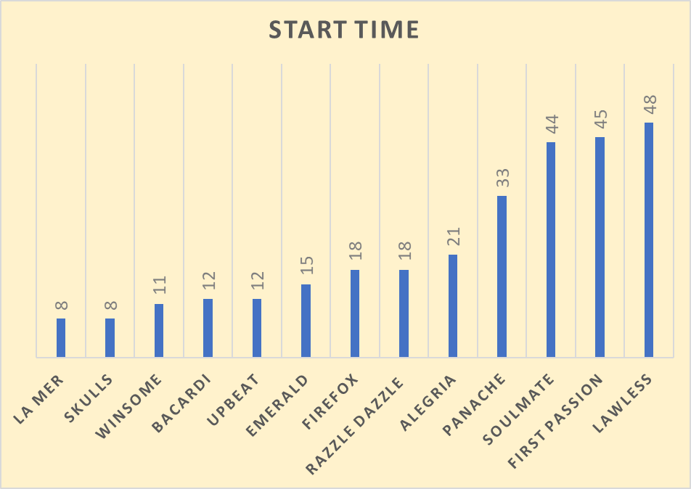
Again starts over a minute are not shown to spare the blushes of the miscreants.

Series: Start of the Day
Best 5 Starts: Skullduggery 25 seconds, Winsome 47 seconds, Firefox 61 seconds, La Mer 78 seconds.

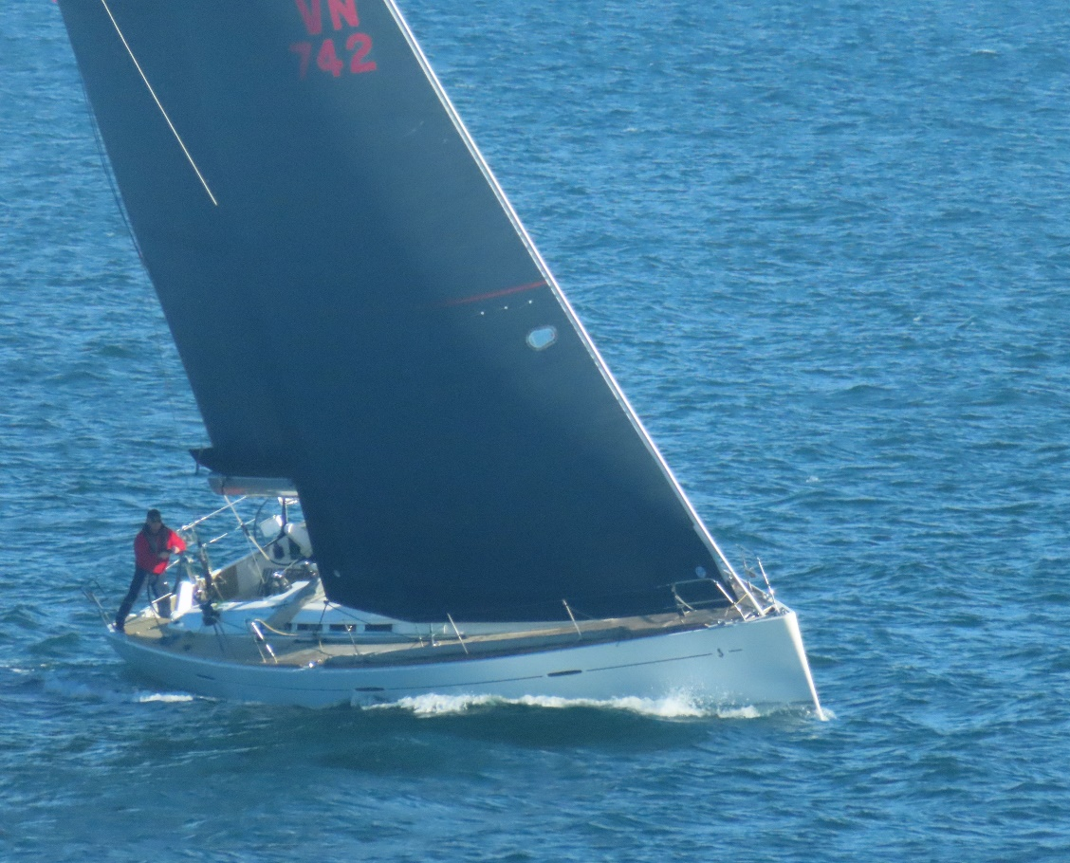
Lumiere placed second and had the fastest elapsed time

A third place for Alliance and crew, a consistently strong race!!.
Elapsed Times
The first 9 boats had elapsed times bracketed by 14 minutes. Lumiere was just fastest (99 minutes) from Bacardi (100 minutes), with Emerald a very good 104 minutes, seven seconds faster than Winsome. Lumiere missed her start by three minutes but was still fastest – Mr Handicapper?? Average elapsed time was 120 minutes, giving a fleet average VMG of 5. 3 knots.

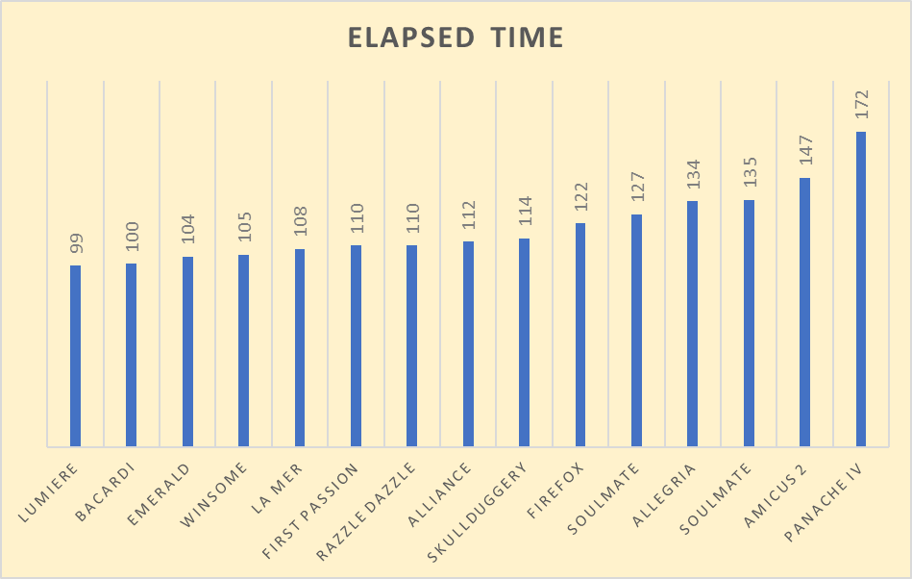

5.3 knots was one of the faster VMG’s, in a race with an average wind strength of 21 knots.

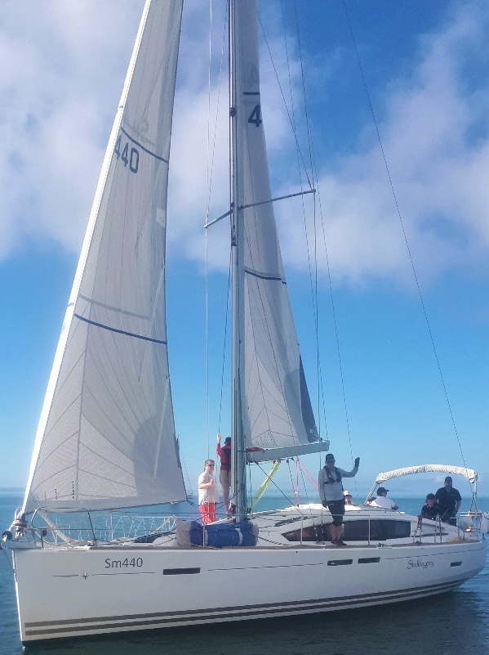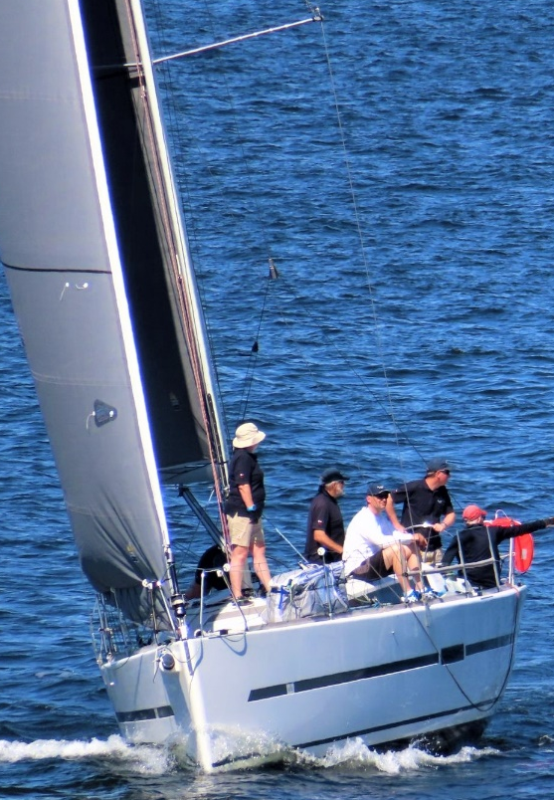

Start of the day shared between Skullduggery and La Mer
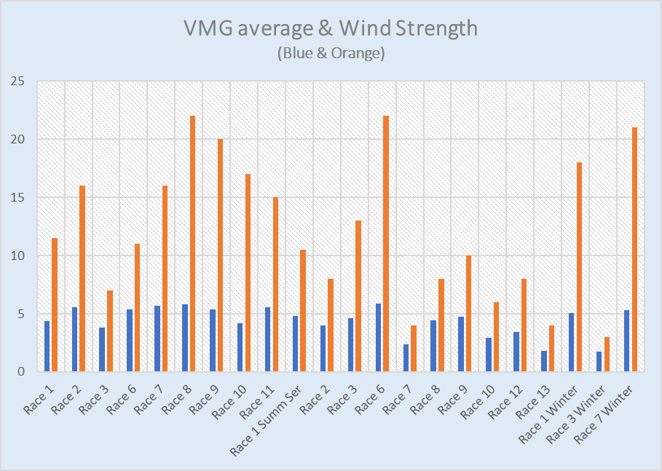

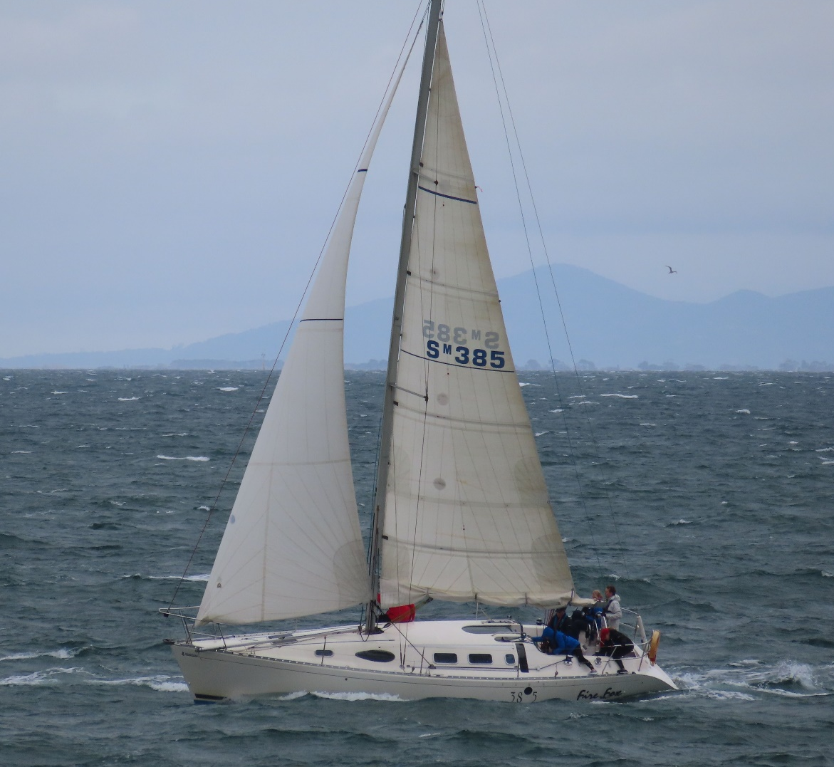

Firefox , placing second in the series

START AND FINISH POSITIONS
The biggest movers in the fleet were Lumiere (14 places), Bacardi (10 places) and Winsome (8 places). Emerald , Alliance and La Mer also faired well. There were two retirements, Upbeat and Hitchhiker in very different circumstances – more on that later!! First Passion (Simon Lipman) copped an ENP, but only dropped 1 place with the 5 minute penalty. Dodged a bullet there!!

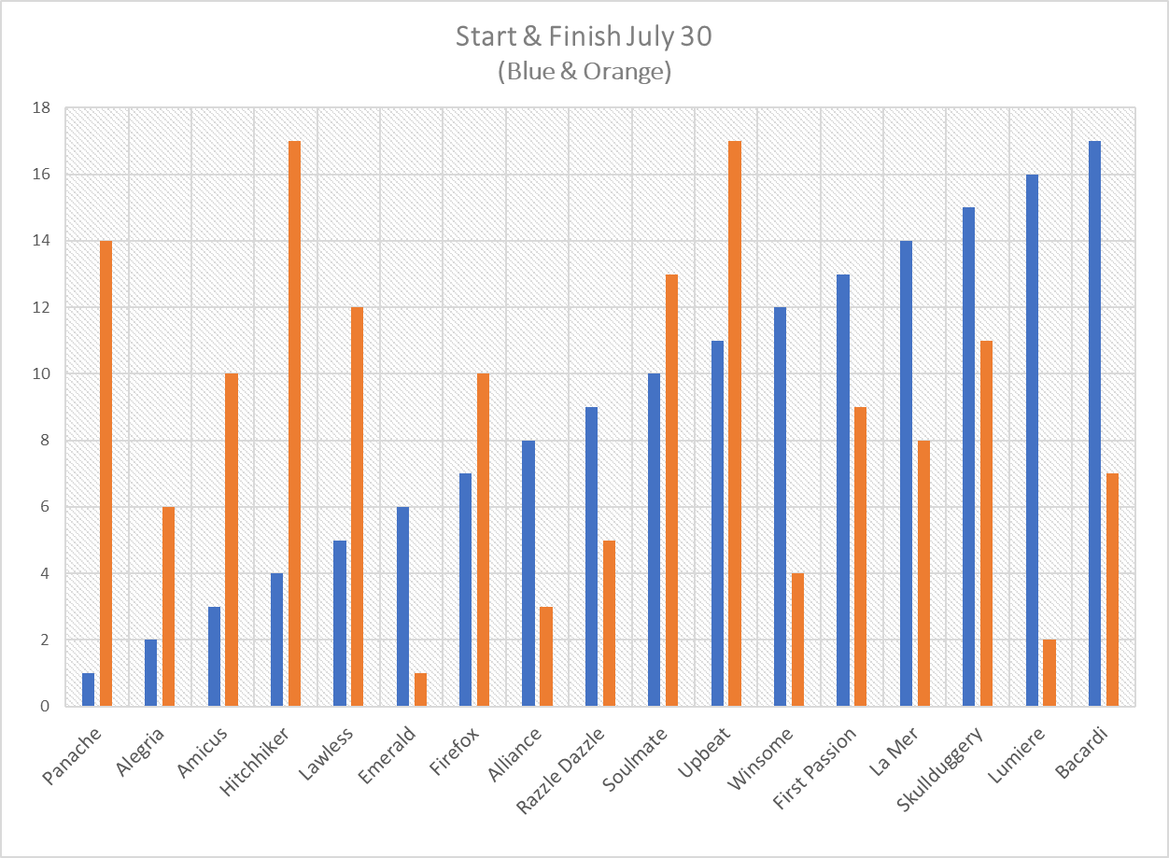

SERIES LEAD

After 7 races (with 1 drop and 1 abn) Emerald leads the way, with a great win in the latest race. Firefox is in second close behind, remembering that they won race 3 by about 10 minutes, and then were disqualified for starting 2 minutes early – they forgot about their spinnaker penalty. Third is the old warhorse Winsome, still in contention with Bacardi also lurking close, in their first Sunday series since, well since your correspondant can remember – going back to at least 2009!!.

Only the latest high tech presentation from your race correspondant!!

Gossip and other matters.
Retirements today: well Peter Dunne, when unwittingly interviewed in the bar afterwards gave several reasons for his retirement. First he was “in a hurry to get to the bar”. Then he thought better of that and decided that when he saw 28 knots on his dial it was time to pack it in. He qualified that by saying he only had 5 on board when he should have had 7 – with two late crew withdrawals. On Hitchhiker it was more traumatic. Fourth place was there for the taking, after sailing well all day. But in the panic caused by the fast approaching Winsome there was an override on the port genoa winch after the final tack to the line. Apparently it couldn’t be cleared and they couldn’t lay the finish mark. My source said, and I quote, “good job it wasn’t my fault or I would have been spoken to “.
Garry McLartin took his spinnaker penalty (I think the only one) and then with great discretion, decided against hoisting the dreaded Black Beast (note the capitals).

Bob the ex- builder sailed on Alliance today so not surprising they had a good showing!!

With thanks to the tower volunteers, Eryl Harris and Christine Walsh, the sponsors Mercedes Benz Brighton and apologies to anyone he feels they have been slandered or misrepresented.

LUFFING LANCE

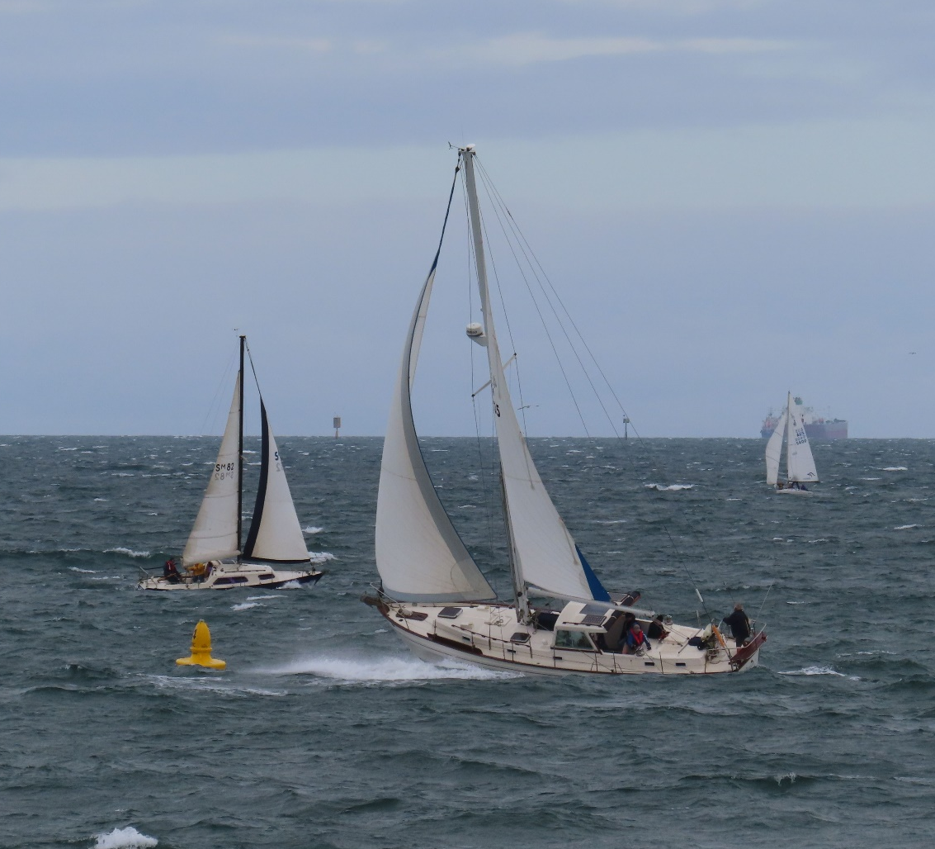

Panache (Egils Stokans) – value for money today. Well sailed.

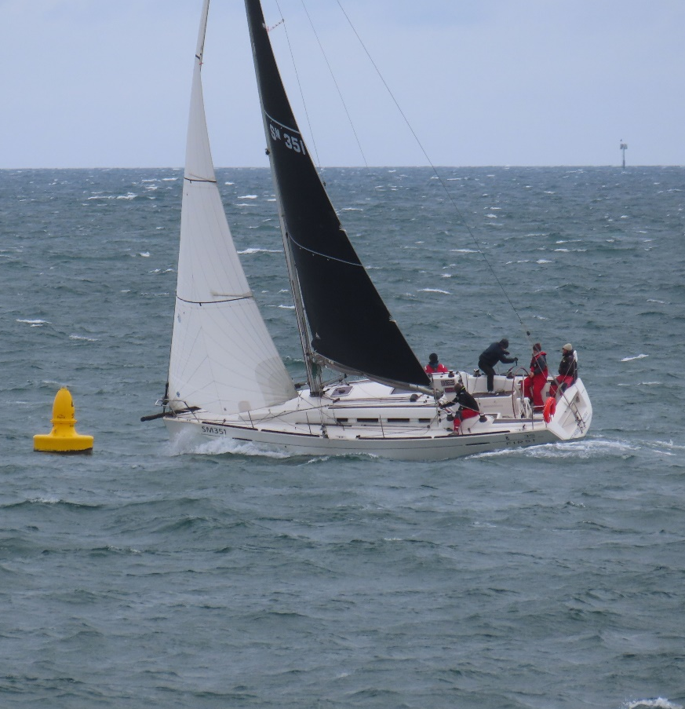

First Passion

