SUNDAY SAILORS SUMMER SERIES 2015-16
AGGREGATE WINNER
COPYRIGHT

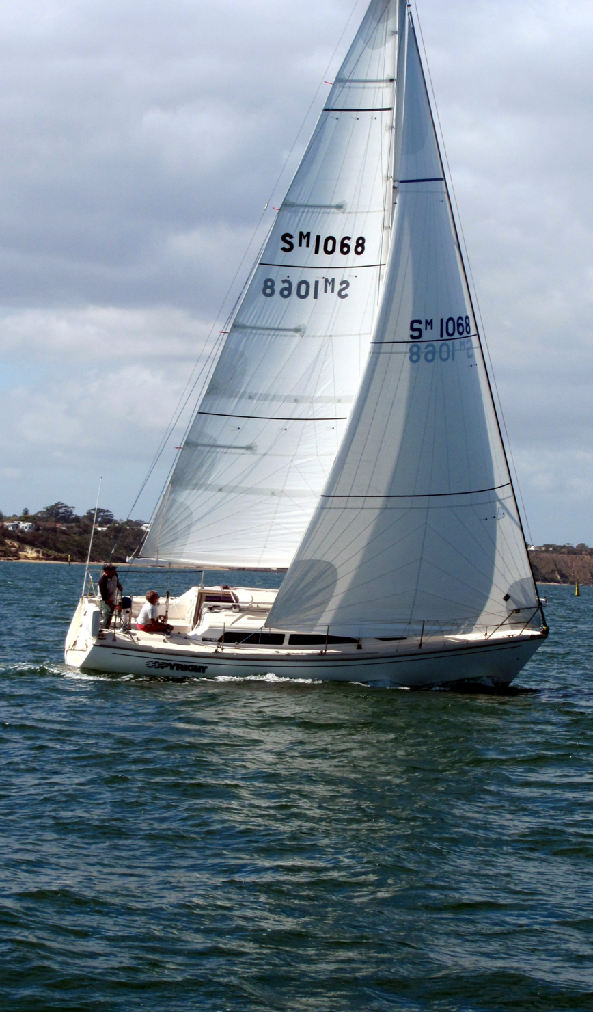

Race 13
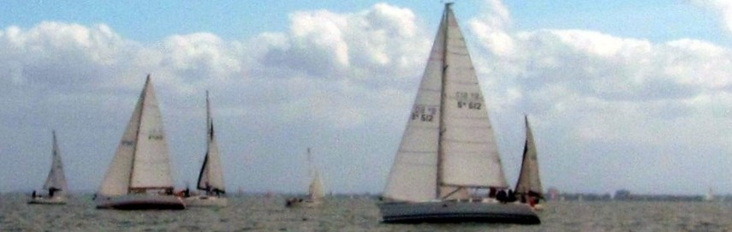
With only 16 yachts in the race this was the smallest fleet of the series. Nevertheless, it proved to be a very pleasant sail which decided the result of the series aggregate. In some ways the race belonged to the first 3 yachts across the finish line. It was the Beneteau 367 LEBROK (Theo Korbel) which won the race in the second fastest elapsed time. The Wright 10 COPYRIGHT (Stuart Morrison Jack) was 2nd in the 3rd fastest elapsed time of the race which was enough to put her on top of the aggregate. The Beneteau First 45 DEBONNAIRE (Phil Gomez) not only won Start of the Day but finished 3rd and recorded the fastest elapsed time of the race.
It was the 7 leg, 8.5 nautical mile course 13 which was selected for the race. It had been sailed on two previous occasions when it was shortened due to light breezes. On this occasion the race ran the full distance, but 2 yachts were unable to finish. One “radioed in” to withdraw from the race whilst the other was narrowly outside the time limit of 1230.
There were gusts at higher speeds but the breeze generally increased as the morning progressed, but did not exceed 10 and averaged 8 knots. It also moved around from the west to finish the morning in the south.

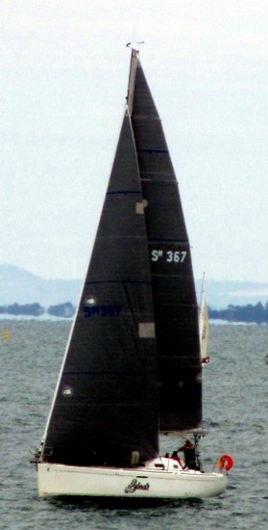
LEBROK is one of 4 yachts eligible for the Noelle Coram Trophy, which is based on the points collected in both the winter and summer series of Wednesday Wonder and Summer Sailors. Lebrok has sailed in 10 of the eleven races in the summer series and recorded 5 top ten positions but this was her first podium finish of the series. She started from 14th place, only 5 seconds late for her 32 minute handicap. By the first rounding of number 4 she was in 7th place, 8 minutes 46 seconds behind the leader. After sailing the course in 1:52:42 she was first across the finish line at 11:54:42. This win raised LEBROK 2 places in the aggregate to finish in 5th position.

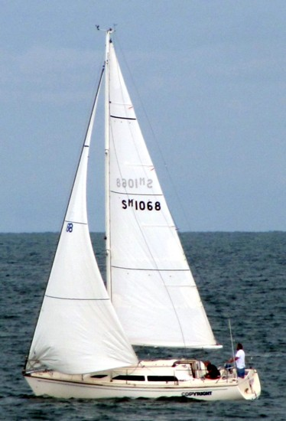
Copyright is one of 4 yachts to have sailed all 11 races in the series. She finished with 7 top ten places and 3 podium finishes in the series. COPYRIGHT started this race 10 seconds late for her 27 minute handicap from 12th place. After sailing for 1:01:02 she rounded number 4 in second place, still 7 minutes 22 seconds behind the leader. COPYRIGHT sailed the remaining 3 legs of the course in 1:01:34 to cross the finish line at 11:59:46 – 5 minutes 4 seconds behind the winner. Her 2nd place was enough to lift her from 2nd to win the series aggregate.
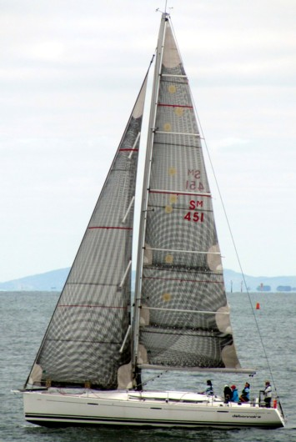
DEBONNAIRE sailed in 9 races and finished 9th in the series aggregate. She was the last yacht to start race 13 starting exactly on her 42 minute handicap. DEBONNAIRE sailed the first 4 legs of the course in 54 minutes 35 seconds, but at the first rounding of number 4 she had moved into15th place. It took 3 minutes 1 second longer to sail the final 3 legs than the first 4. DEBONNAIRE crossed the finish line in 3rd place at 12:04:11 to record her second podium finish of the series. Her other podium finish was recorded in the first race of the series.

With all 16 yachts starting within 49 seconds or less of their handicaps this was one of the better starts to a race this series. The median start time was 13 seconds.

The fleet started the race 43 minutes 52 seconds apart and finished 34 minutes 29 seconds apart, after being 18 minutes 22 seconds apart at the first rounding of number 4. The closest finish was between WINSOME and SCALLYWAG who finished 9 seconds apart in 7th and 8th place respectively.

It was not the best race for yachts with an early start but yachts that started later fared much better. Of the first 5 yachts to cross the finish line 3 were among the last 5 to start with 2 starting mid fleet.

For the 6th time in 9th attempts DEBONNAIRE was the fastest yacht around the course beating LEBROK by 31 seconds. These two yachts were more than 10 minutes faster than COPYRIGHT who was 2nd in the race. The average elapsed time was 2:21:27 – the longest of the series.

Sunday Sailors Summer Series 2015-16 – Yacht Summary
YACHT | SKIPPER | Nos of Races | Ave HCAP | Aggregate Position | Ave Finish Position | Ave Start Seconds
COPYRIGHT | Stuart Morrison-Jack | 11 | 27:05 | 1 | 8.45 | 25.27
FOGGY DEW | Frank Hilliard | 11 | 15:49 | 6 | 10.18 | 25.36
L ATTITUDE | Peter Gray | 11 | 22:16 | 4 | 8.91 | 62.45
WINSOME | Simon Hemingway | 11 | 36:00 | 7 | 10.45 | 12.82
CASSANDRA MELBOURNE | Bob Reeves | 10 | 13:12 | 2 | 7.80 | 44.82
DILII GAFF | Paul Macbain | 10 | 19:30 | 3 | 8.00 | 27.00
LEBROK | Theo Korbel | 10 | 31:54 | 5 | 9.20 | 80.90
SKULLDUGGERY | Garry McCarten | 10 | 28:00 | 11 | 12.80 | 25.30
DEBONNAIRE | Phil Gomez | 9 | 43:07 | 9 | 10.22 | 29.89
SCALLYWAG | Bill Hutchison | 9 | 26:13 | 8 | 9.67 | 30.44
SILVERADO | John Barbieri | 9 | 19:13 | 10 | 11.00 | 41.89
ANTARES | G Stewart D Pearce | 8 | 02:23 | 14 | 13.13 | 63.50
HIGH HANDED | Guy Dwyer | 8 | 01:22 | 13 | 12.38 | 43.75
OASIS | David Keyes-Tilley | 8 | 30:00 | 12 | 11.38 | 64.00
CADENZA | Kenneth Foxworthy | 7 | 00:17 | 18 | 13.86 | 56.75
IMAGINER | Chris Byrne | 7 | 25:17 | 15 | 11.43 | 58.00
KAOS | Dawn Cleaver | 7 | 05:51 | 17 | 12.57 | 25.00
ISA LEI | Andrew Chapman | 6 | 01:20 | 19 | 12.33 | 30.71
MYUNA III | Geoffrey Nixon | 6 | 25:00 | 16 | 8.50 | 20.33
SHILO | Doug Jackson | 6 | 06:10 | 21 | 15.50 | 30.38
WINEDOWN | Brian Horley | 5 | 20:00 | 22 | 11.80 | 42.00
AMICUS II | Warwick Stenford | 4 | 08:45 | 23 | 7.25 | 47.50
DELL ERA | Mike Coulter | 4 | 10:30 | 25 | 16.25 | 46.00
PANACHE IV | Egils E Stokans | 4 | 00:45 | 20 | 9.25 | 54.00
PLAY | Ian Pridgeon | 4 | 07:45 | 24 | 9.75 | 18.80
INDEPENDENT ENDEAVOUR | Malcolm Mohr | 3 | 32:00 | 26 | 12.67 | 134.00
VANQUISH | Bob Beresford | 2 | 02:30 | 27 | 7.50 | 54.00
A CUNNING PLAN | Jon Lechte | 1 | 48:00 | 28 | 14.00 | 12.00
NOELLE CORAM TROPHY WINTER 2015 & SUMMER 2015-16
 | Sunday Sailors |  | Wednesday Wonders |  | TOTAL
YACHT | Winter 2015 | Summer 2015-16 | Winter 2015 | Summer 2015-16
FOGGY DEW | 58 | 68 | 110.5 | 85.5 | 322
CASSANDRA MELBOURNE | 76 | 54 | 134 | 76.5 | 340.5
LEBROK | 70 | 67 | 171 | 148 | 456
MYUNA | 127 | 134 | 230 | 166 | 657

This was a fascinating series that attracted 29 yachts in the aggregate, as well as 8 visitors. On average, 21 yachts contested each of the 11 completed races. By the time of the 7th race, it appeared that the minimum number of races may not be reached. Two races were abandoned due to strong winds, and four races shortened due to insufficient wind. As it eventuated the remaining races were completed with only one of them being shortened.
The average course length was 7.5 nautical miles per race the same as in the previous winter series. The average elapsed time for the winter series was 1:59:03 compared to the shorter 1:56:51 for this series. Eight different courses were selected throughout the series with course 13 (6 leg, 8.5 nautical mile) being the most popular. The average wind speed for the series was 12 knots which was the same for the winter series.
There were 9 different winners of Start of the Day. Two yachts, SHILO and PLAY each won the start on 2 occasions. There were 21 different winners of the 33 podium places on offer. The multiple winners were CASSANDRA of MELBOURNE, COPYRIGHT and DILII GAFF each having three podium finishes, whilst SCALLYWAG, DEBONNAIRE, ANTARES, PHOENIX, WINSOME and PANACHE IV each had 2 podium finishes. There were 8 different race winners with CASSANDRA of MELBOURNE recording 3 wins and PHOENIX recording 2 wins.

The NOTICE of RACE for the Winter Series is already available on the SYC website. The series comprises 11 races with the first race scheduled for 1 May 2016.

